**IBM- Naan Mudhalvan Data Analytics with Cognos**

**Phase 4**

**Development Part 2**

**Student Name :** Badhrinathan N

**Register Number :** 620821104015

**Branch :** B.E CSE

**Year :** 3rd Year

**Topic :** Data Analytics with Cognos

**Title :** Web Traffic Analysis

**College :** Gnanamani College of Technology

**Objectives**

In this phase defines the visualization using IBM cognos, Integrating python code for advanced analysis and creating interactive dashboard. Use Python libraries and machine learning models for Complex analysis

**Visualization in IBM Cognos**

**Step 1:**

1. Login to your IBM cognos
2. Click more menu from the left side
3. Select new tab
4. Click Dashboard tab

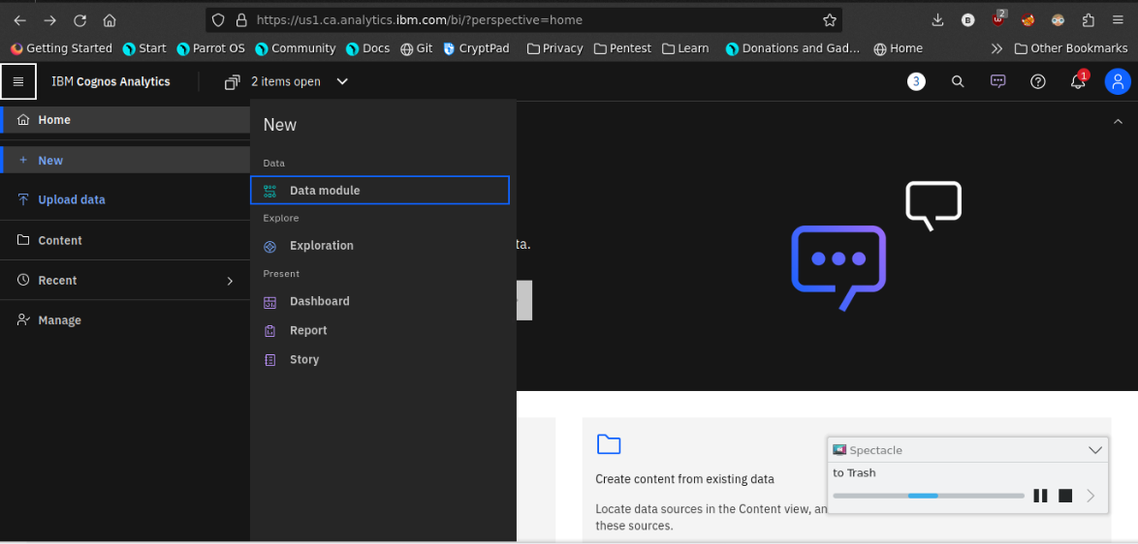

1. Select Template for your dashboard

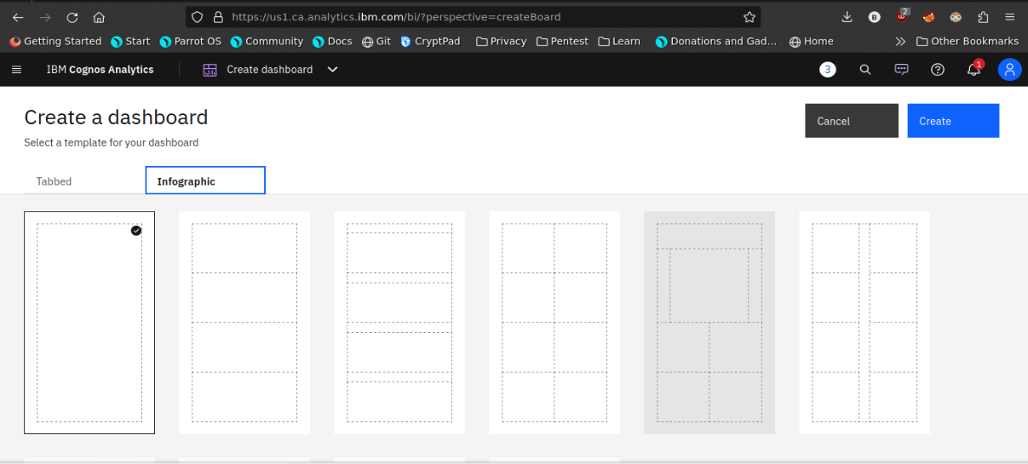

1. Now the dashboard is created and select your data-source.

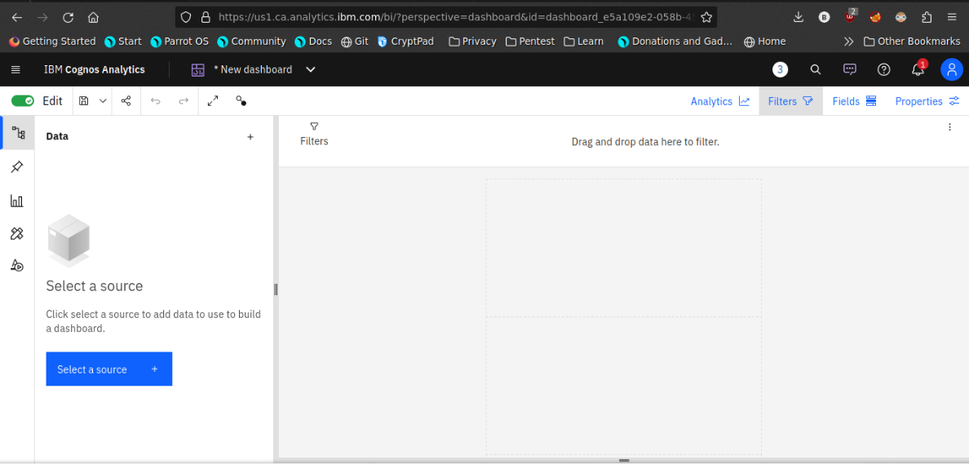

1. Select your Corresponding dataset

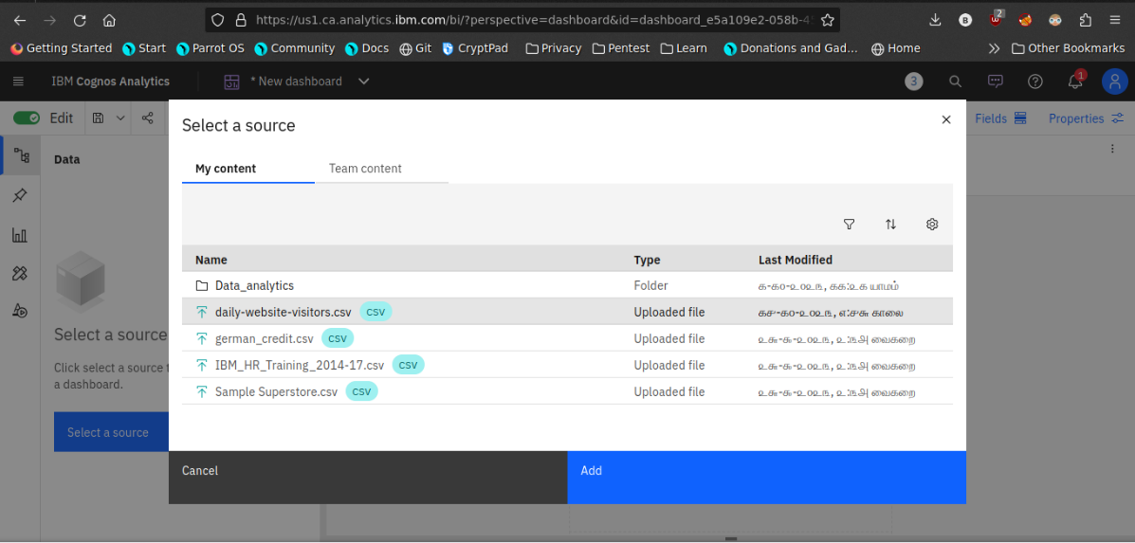

1. Select favourable visualization system

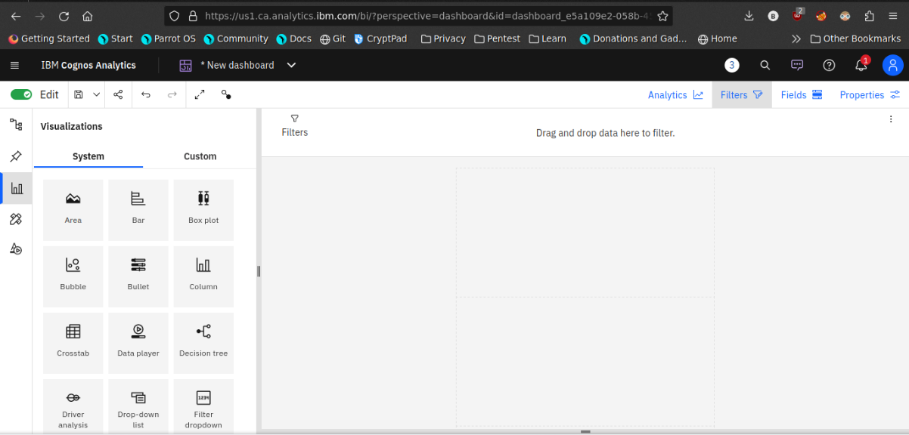

1. If needed Filter the data

Here the datasets are filtered by the date Which contains 2020

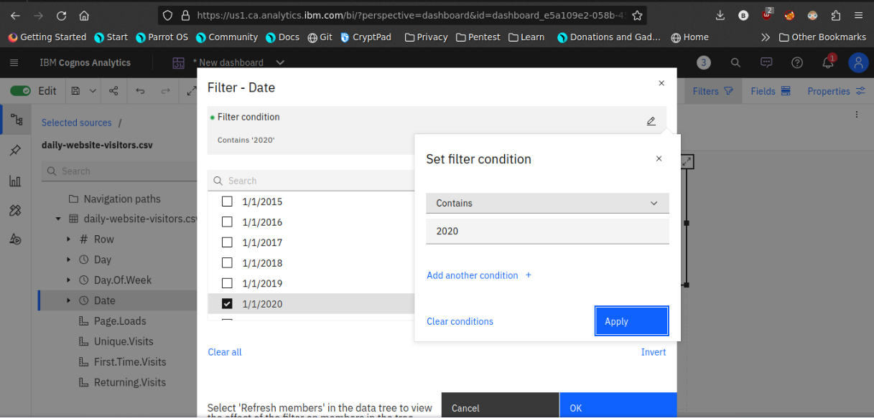

1. Line plot

In this line plot X_axis are dates and Y_axis are First time visits and Unique visits

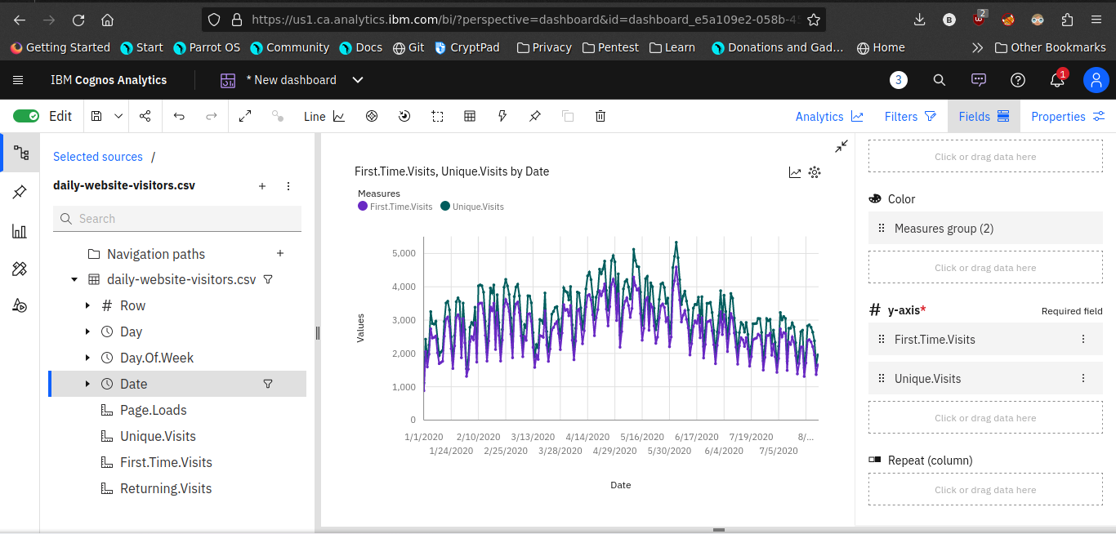

1. **Barchart**

In this Bar chart the bars represent the ‘days in week’ and length defines ‘Page.Loads’

It helpful to visualize the maximum pageloads occurs on a day

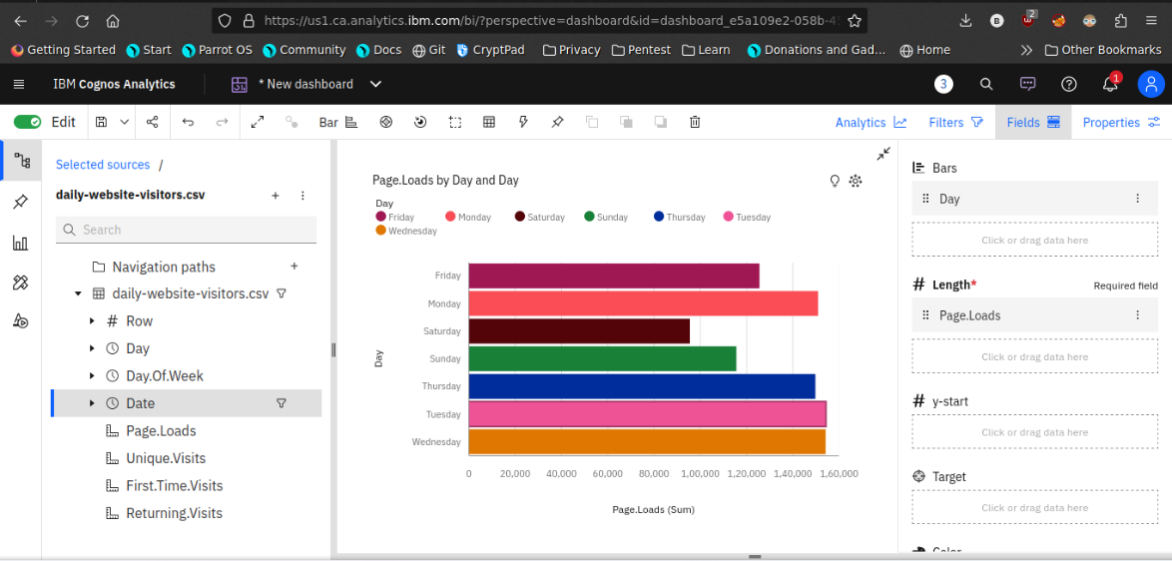

1. **Pie chart**

This is same as a bar chart. it helpful to analyze the Returing visits occurs on a particular day

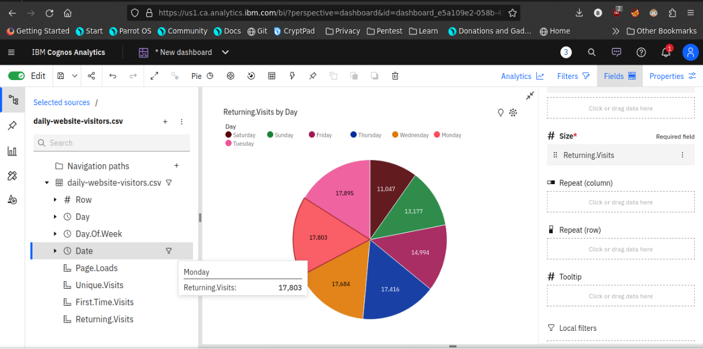

1. **Scatter plot**

It is used to display the relationship between two variables and observe the nature of the relationship. The relationships observed can either be positive or negative, non-linear or linear

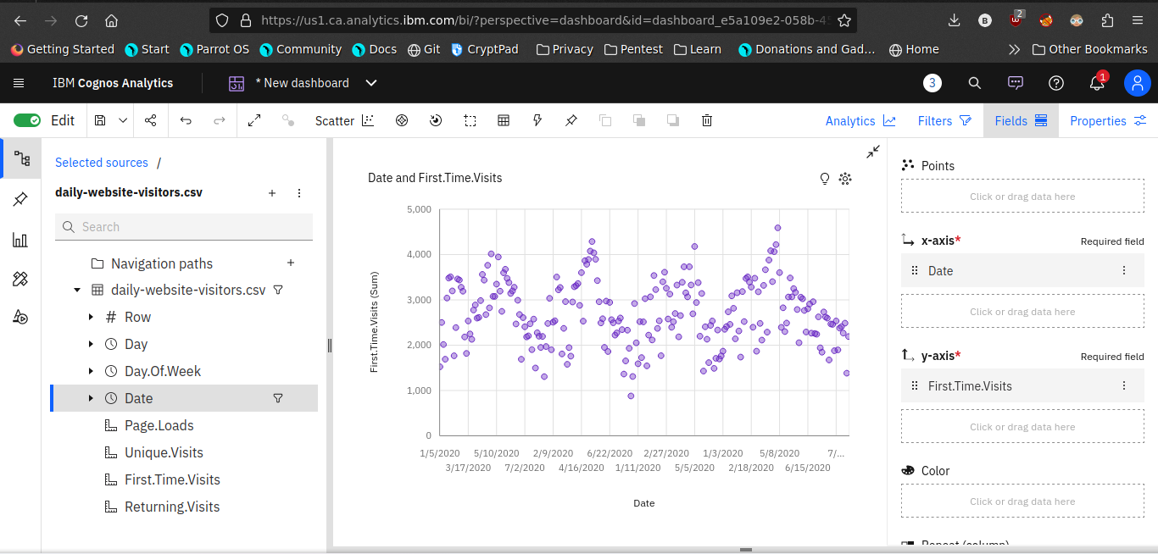

1. After completing the dashboard lets export to another format

Like pdf

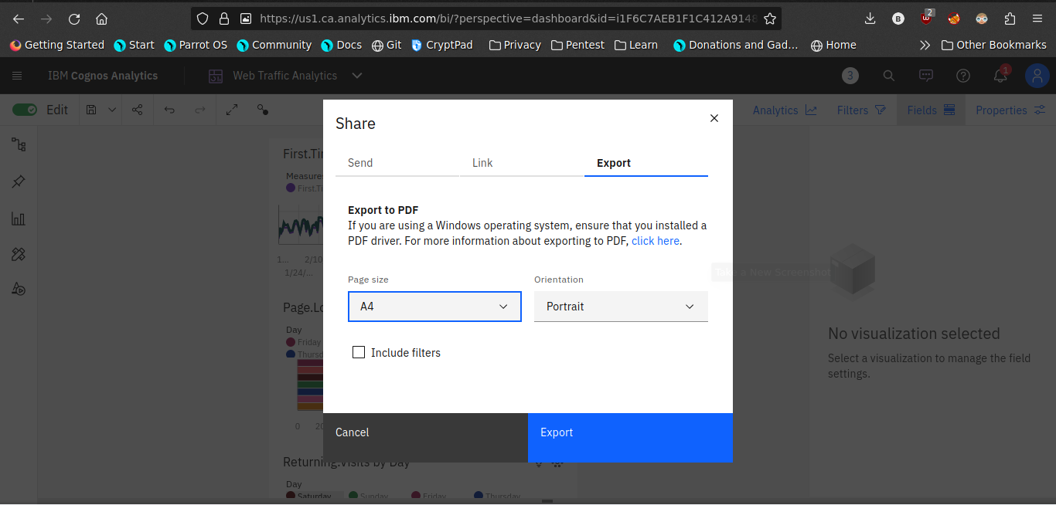

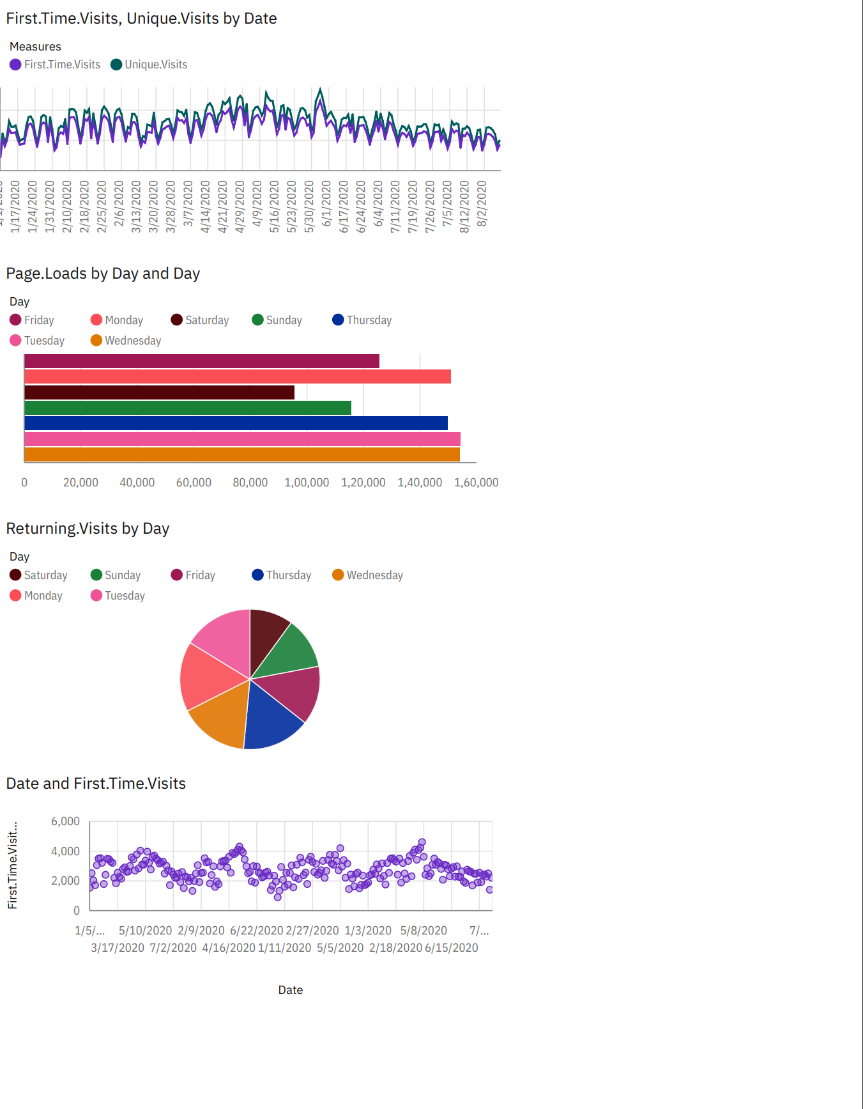

Now the visualization phase where over. lets start analyze the dataset using Python libraries use machine learning models for predictive analysis.

**Data Analysis using python**

In this steps are used to analyse the given dataset using python libraries

**Steps:**

1. **Import Necessary packages**

Pandas

seaborn

Machine learning models

Linear regression

1. **Make a training and test data**

Use the train test split model

Compare the testing and training data set by visualization library

1. **Calculate the accuracy of the model**

Use r2_score to measure the accuracy of the model

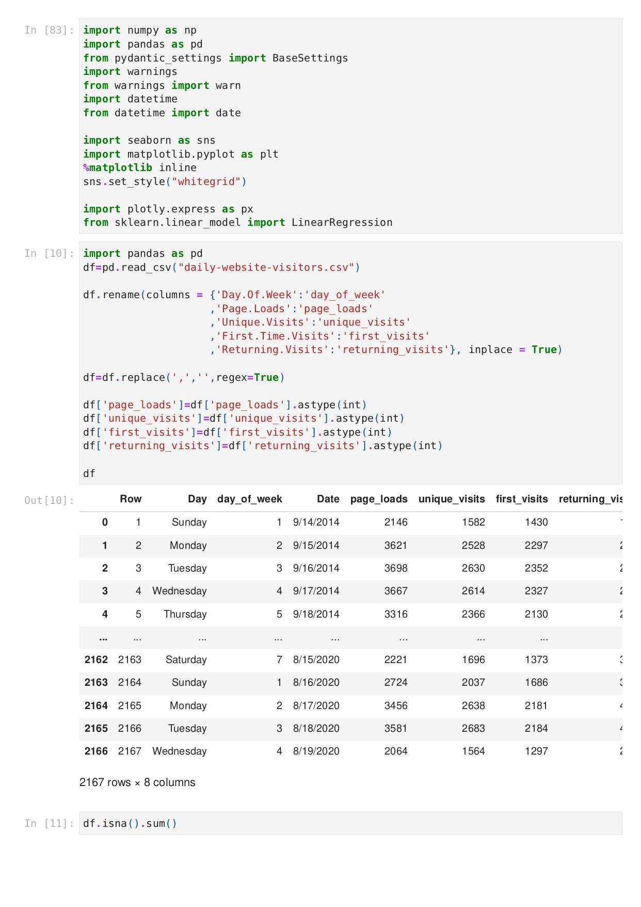

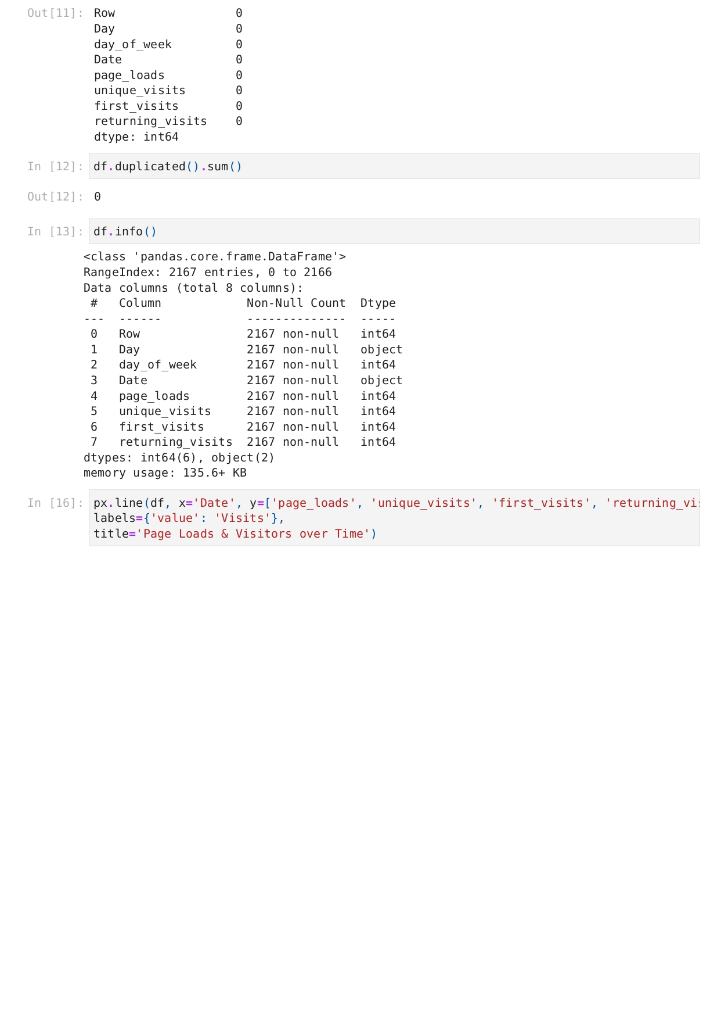

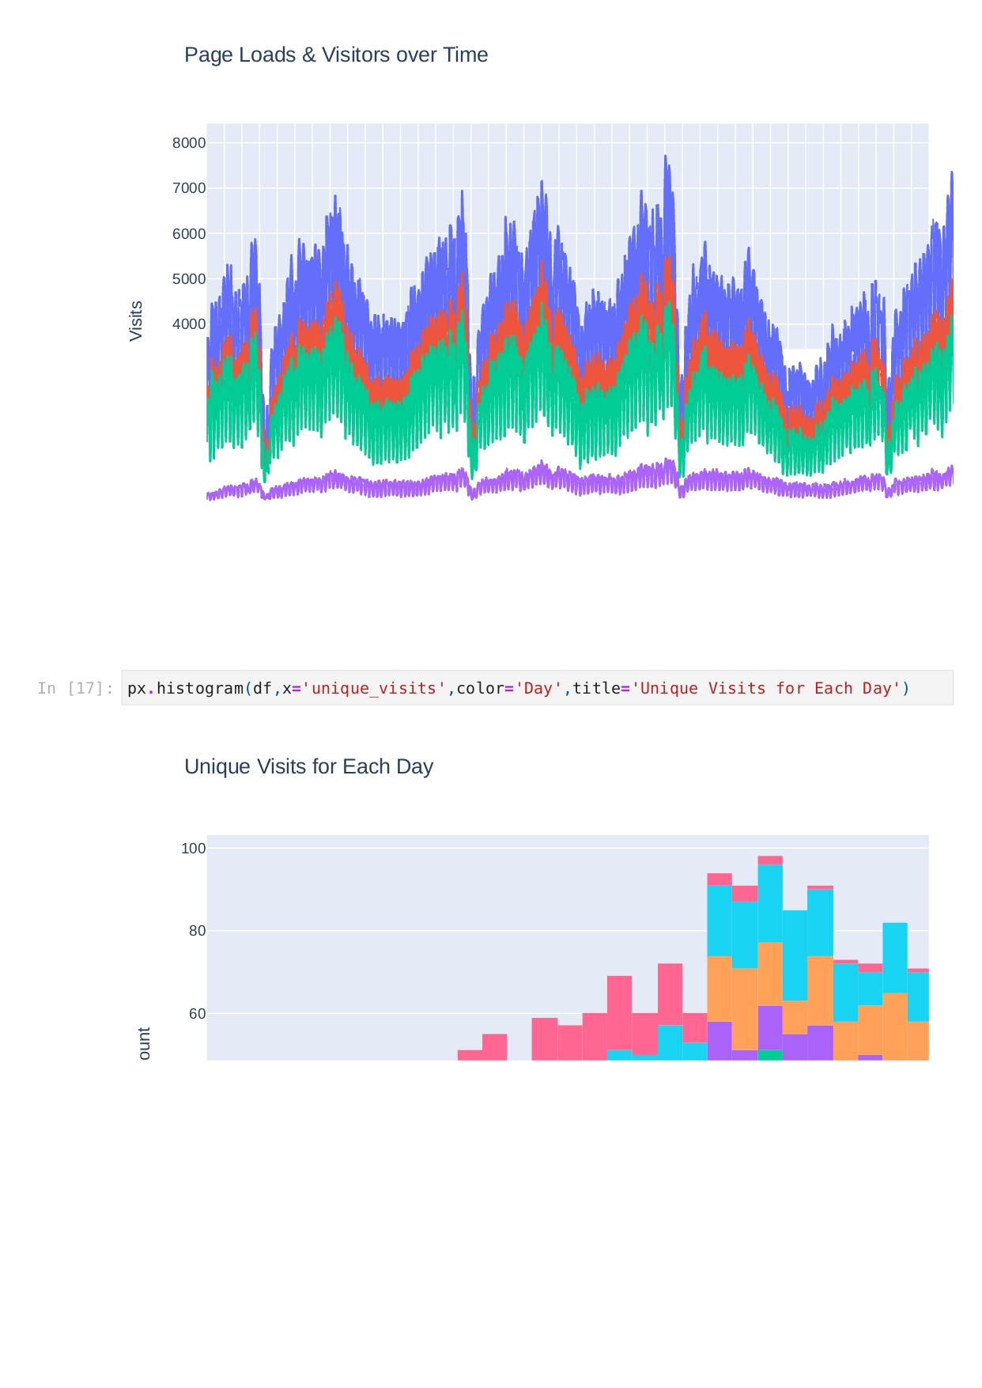

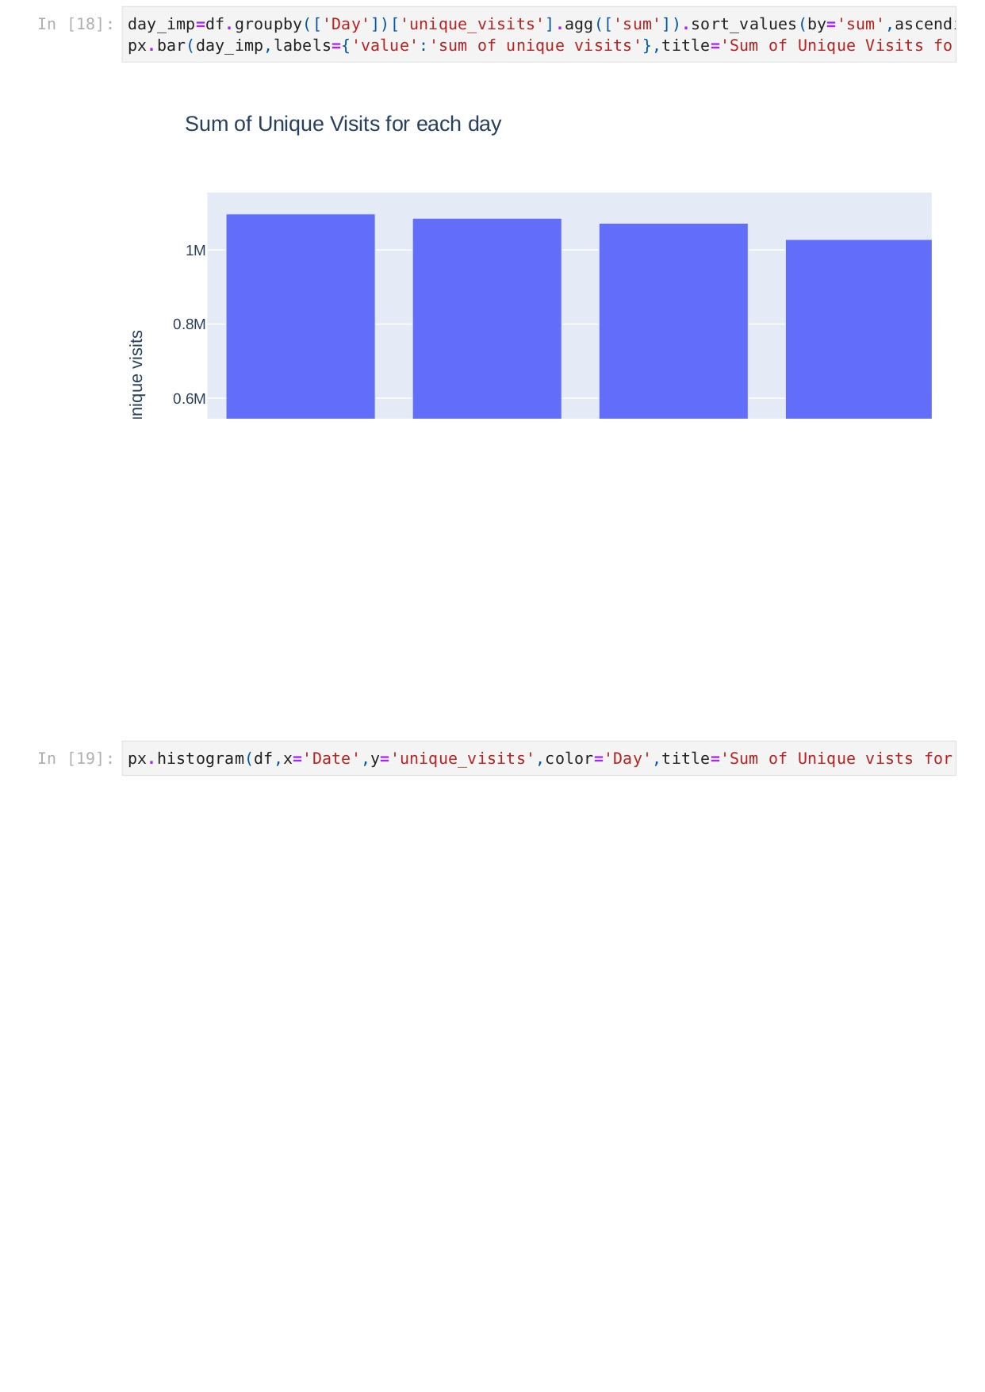

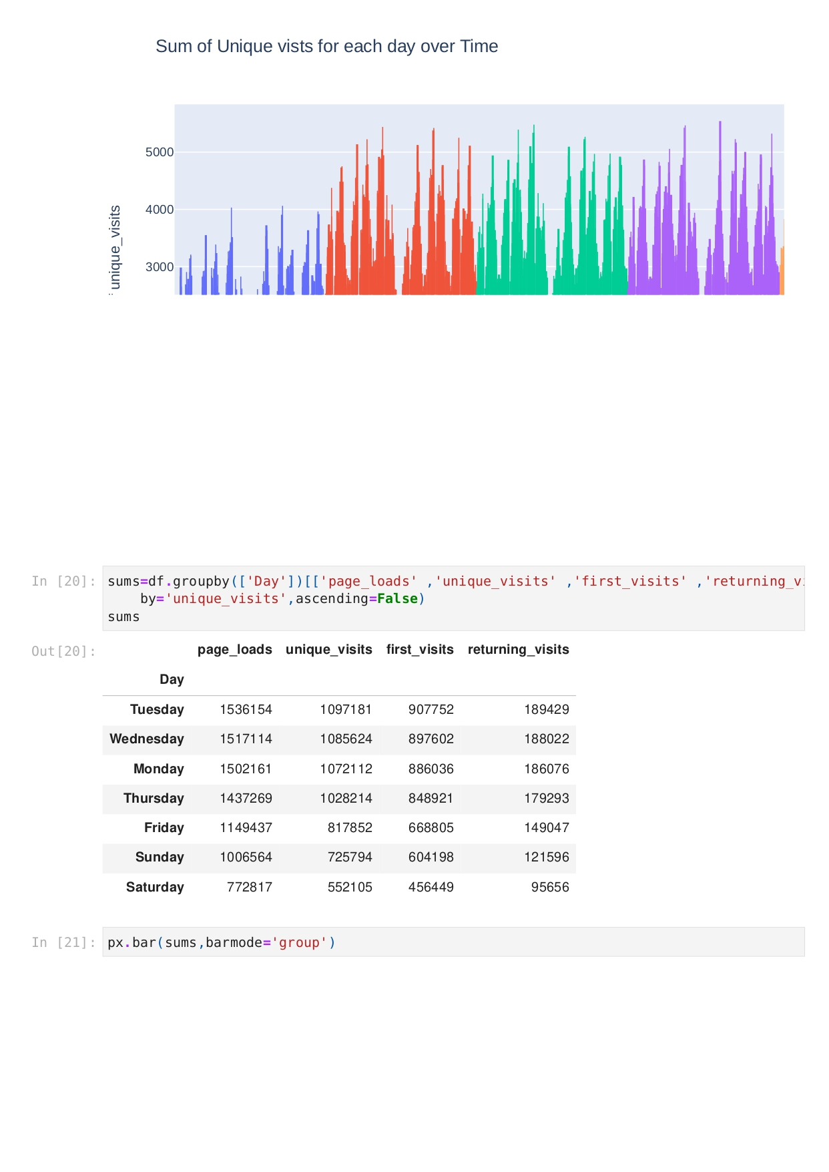

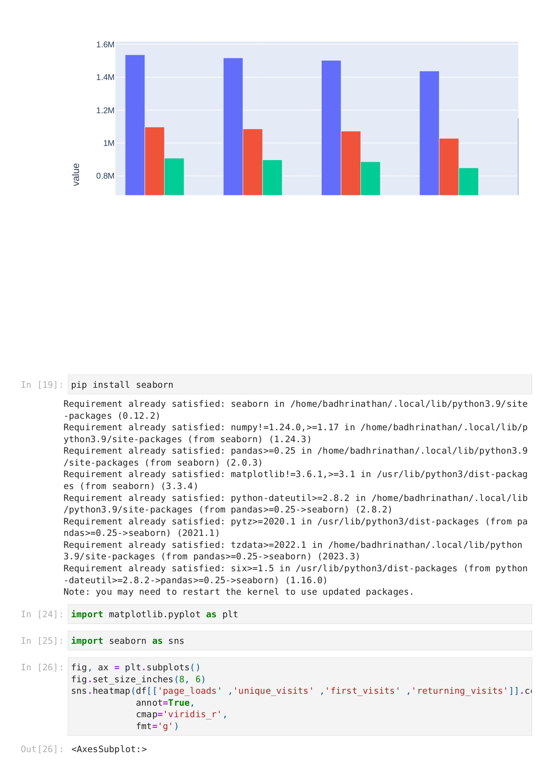

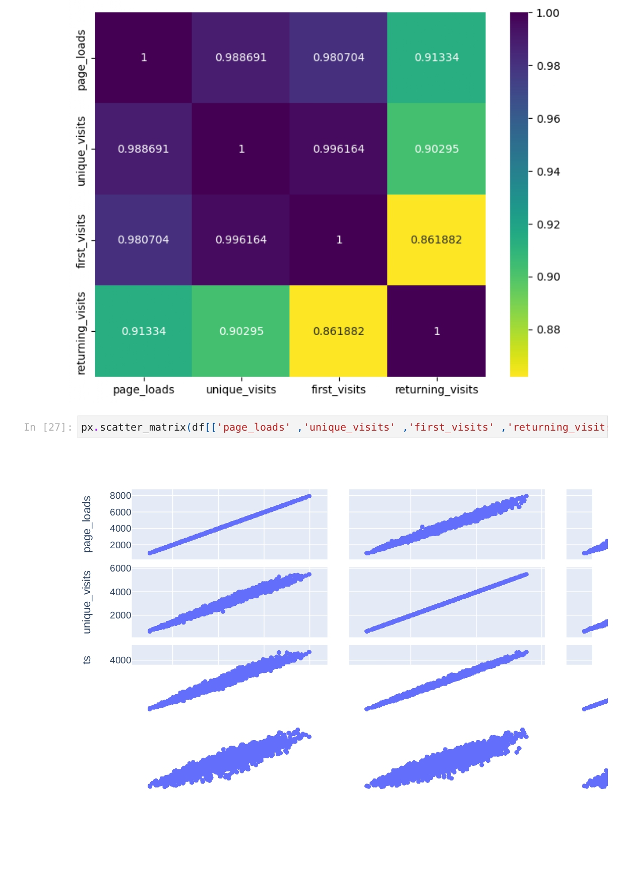

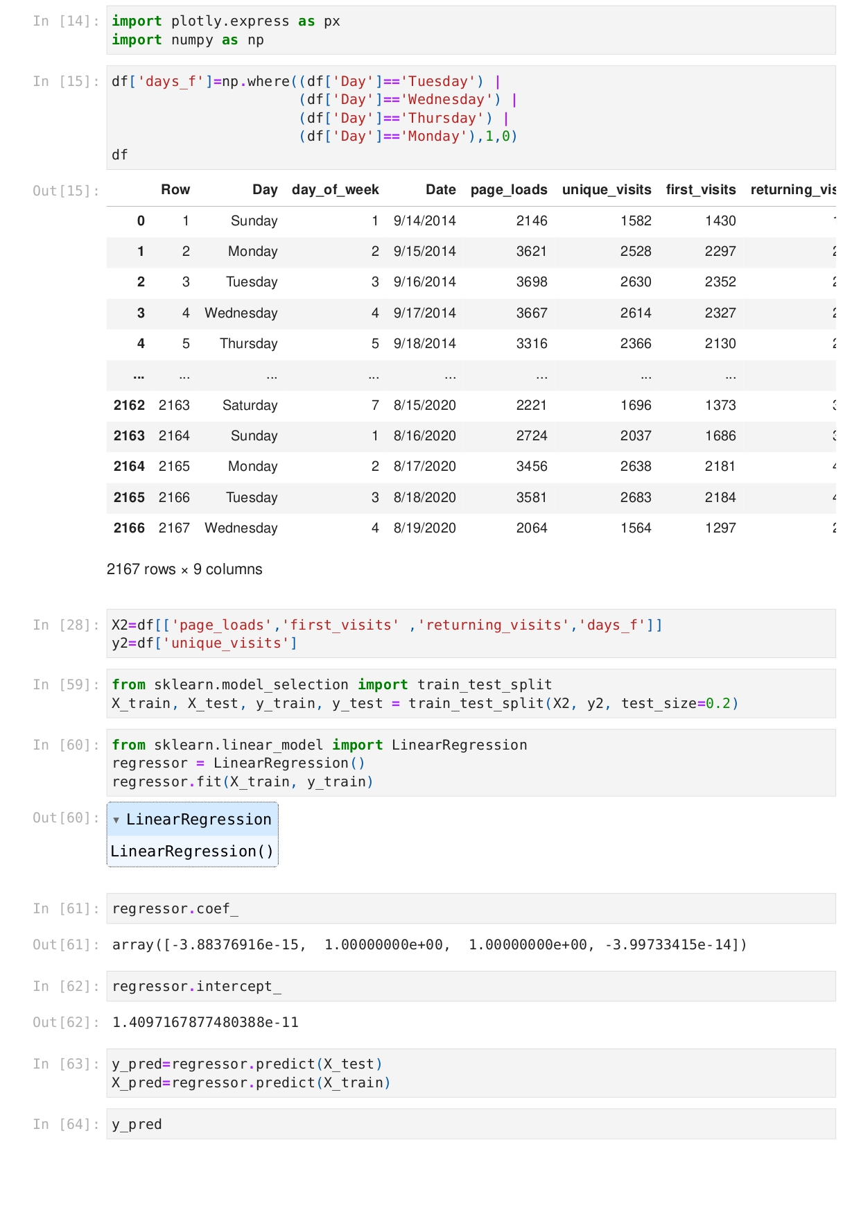

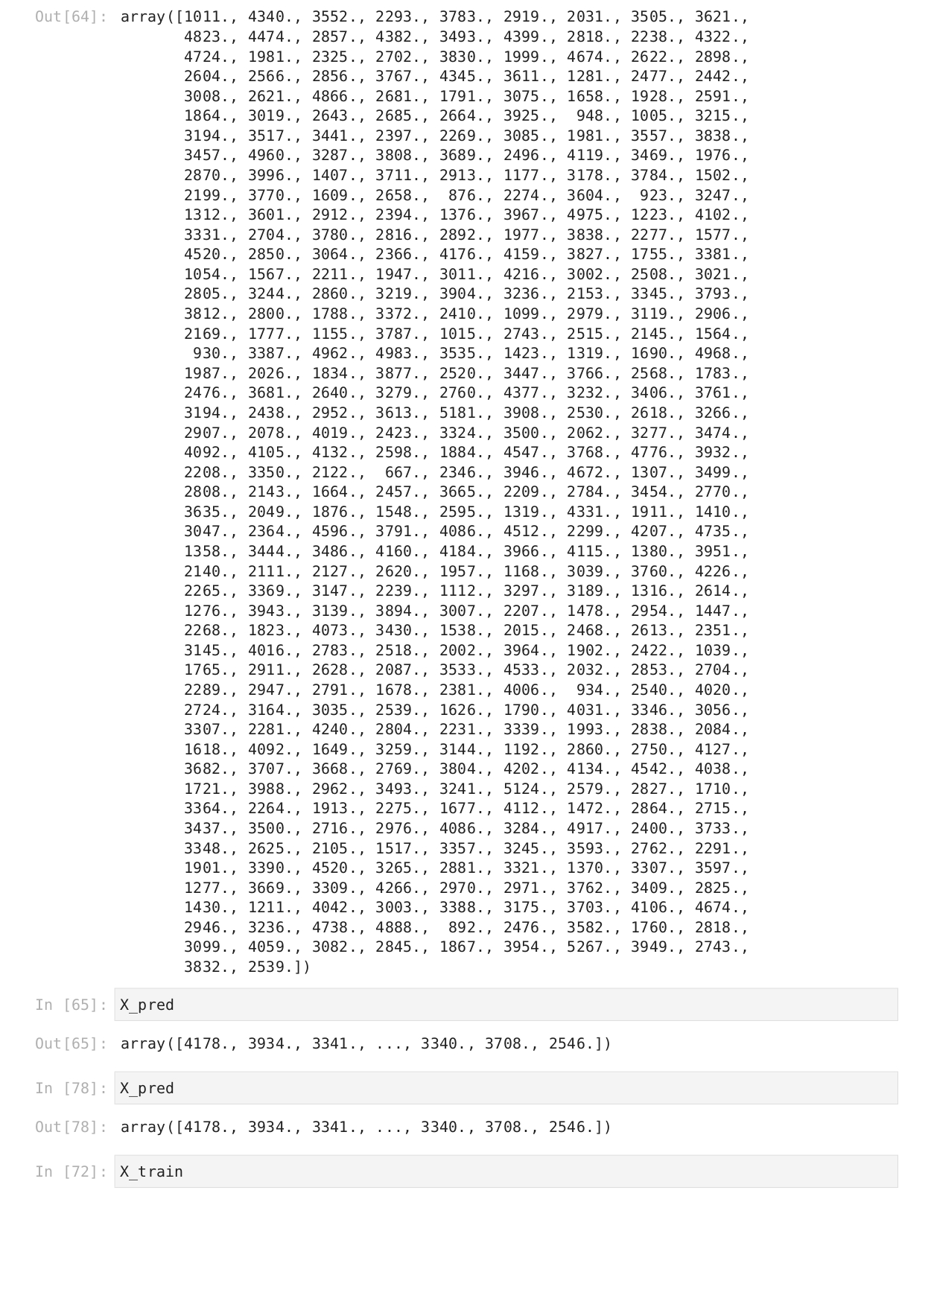

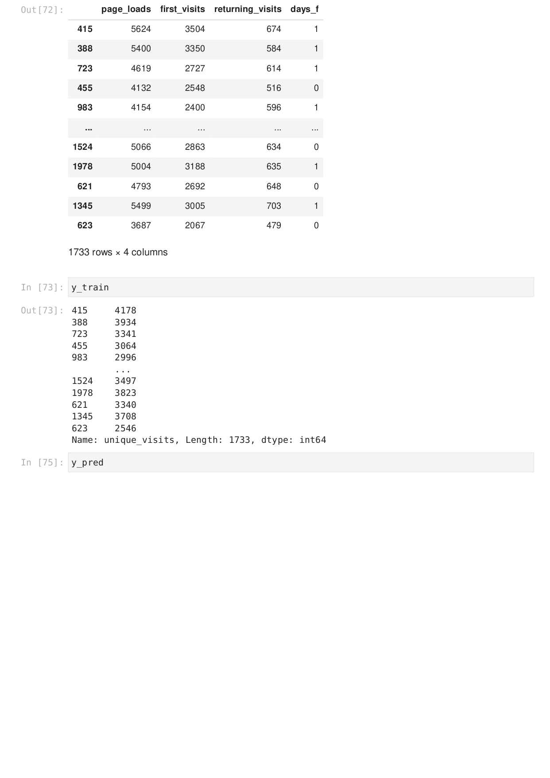

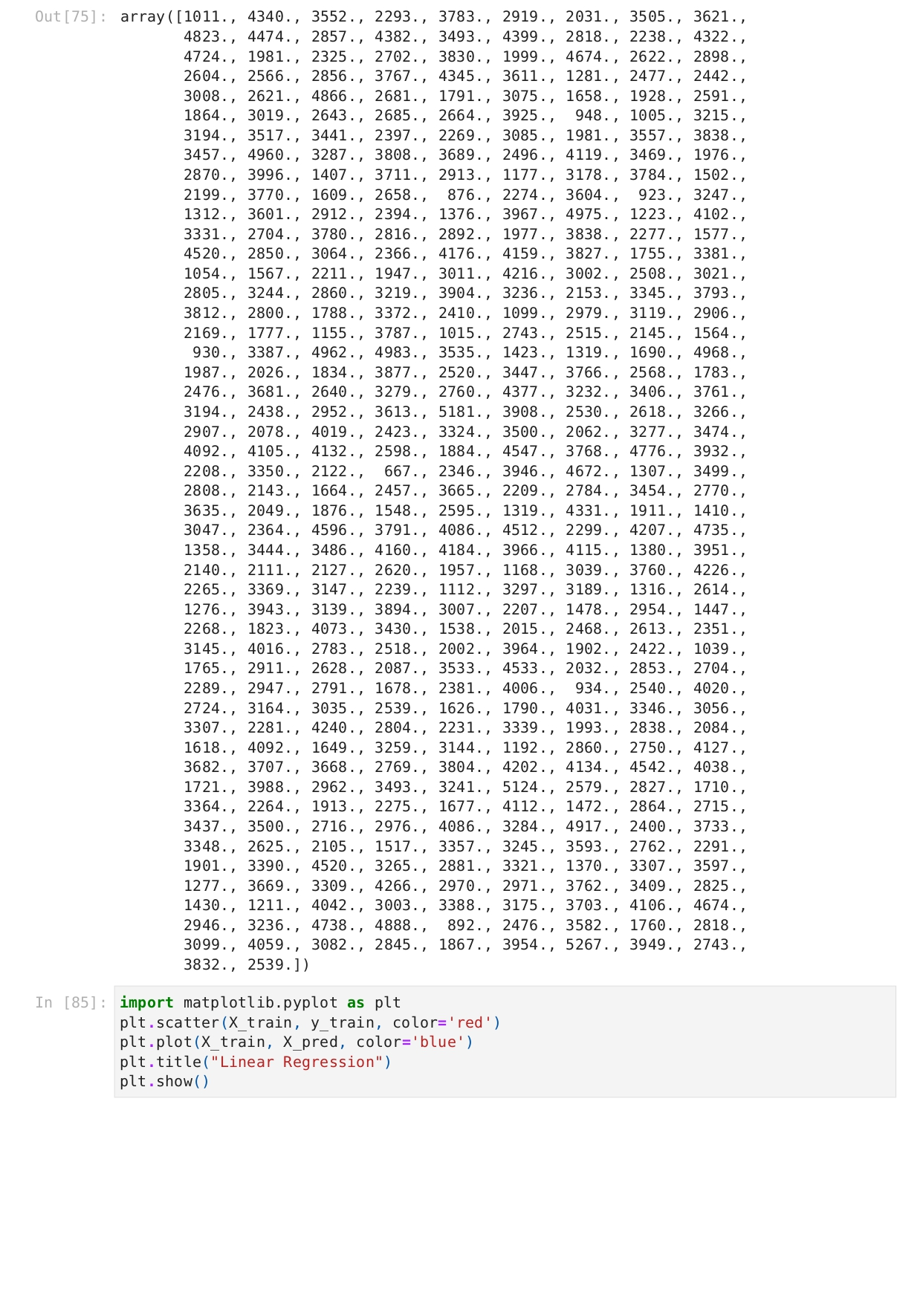

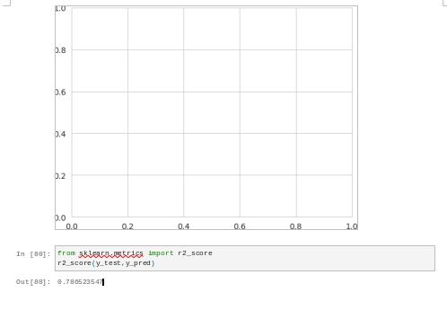

The accuracy for the above machine learning model is

0.780523547

**Conclusion**

This technology project Involves loading and preprocessing a dataset, followed by various analysis and visualizations using IBM Cognos. helpful to make an data-driven decisions and responsive the web Traffic trends